Most organisations are deploying AI faster than they have built the institutional capacity to govern it. That gap is what responsible AI exists to close. The discipline is sometimes framed as a brake on innovation, sometimes as a compliance exercise that catches up after a model has already shipped. Both framings miss the point. Responsible AI is the set of practices that decide whether an AI system remains trustworthy a year into production, not just at launch.

1. What is Responsible AI?
Responsible AI is a set of principles and operational practices for designing, building, deploying, and monitoring AI systems so that they remain fair, safe, transparent, and accountable across their working life. It is often confused with AI ethics, which it borrows from but is not the same thing: AI ethics is the philosophical question of what AI systems ought to do, while responsible AI is the engineering and governance work that makes those answers enforceable inside an organisation.
Two clarifications matter early. First, responsible AI is not a one-time audit. A model that was responsible at launch can drift into unfairness later, and a framework that treats responsibility as a launch checklist will miss it. Second, the principles are not a single industry standard yet. IBM presents them as pillars of trust, AWS frames them as eight dimensions, and Google organises them around fairness, safety, interpretability, and responsible data practices. The vocabulary varies, but the substance overlaps closely.

2. Cornerstones of Responsible AI
Despite differences in vocabulary across IBM, AWS, Google, and the ISO 42001 standard, the substance converges on six properties that any AI system should be evaluated against before being trusted with consequential decisions.
Figure 1: Six cornerstones of Responsible AI
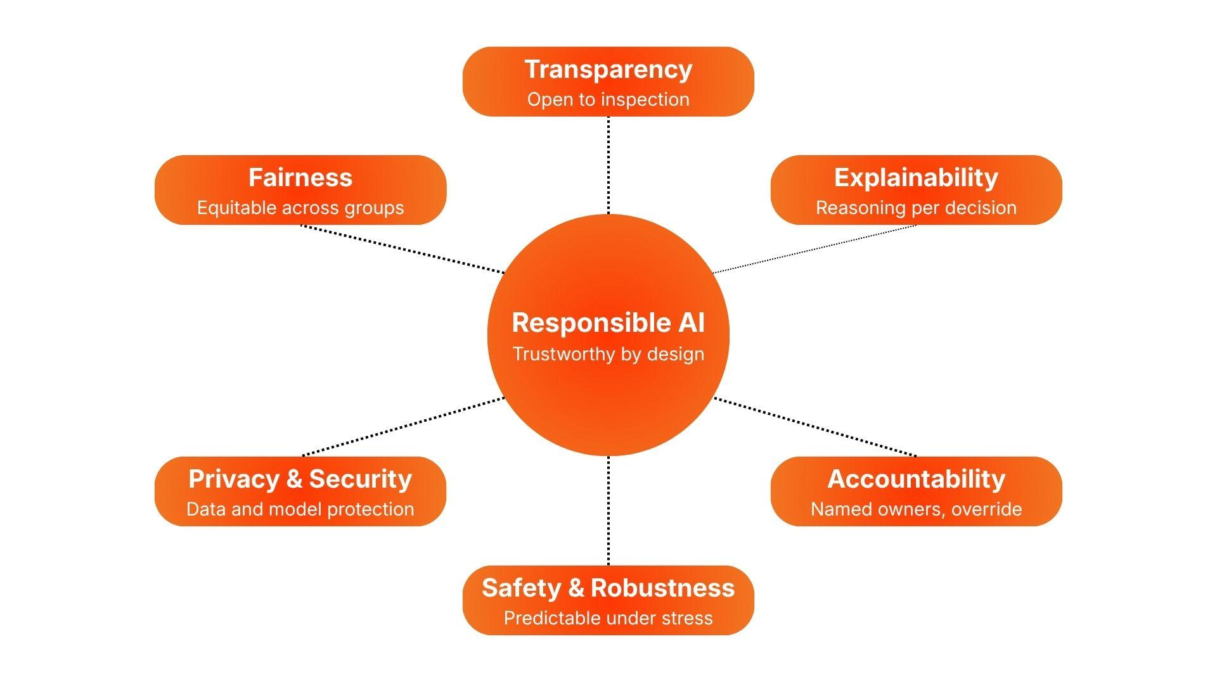
Fairness. Machine learning systems inherit patterns from their training data, and can amplify them or create new unfairness through feedback loops and distribution shift. A hiring model trained on historical decisions reproduces those biases unless someone designs against them. Fairness in practice means representative data, subgroup metrics, and continued monitoring, since a system fair at launch can stop being fair months later.
Transparency. Systems making consequential decisions about people have an obligation to be inspectable by those people or by institutions representing them. Transparency means documentation of training data, model cards covering known limitations, and version histories that let auditors trace changes. The standard does not demand model weights; it demands that when a decision is challenged, the organisation can answer how the system reached it.
Explainability. Transparency is about the system as a whole; explainability is about the individual decision. There is often a perceived tradeoff between accuracy and interpretability for deep neural networks, though research has shown interpretable models can match black-box accuracy in some structured-data problems. Where a decision cannot be explained to the person it affects, it probably should not be made by AI alone.
Privacy and security. Training data is data about real people, and that does not stop being true once it has been absorbed into a model’s weights. Attacks like membership inference, model inversion, and prompt injection can pull out information assumed to be safely buried. This cornerstone covers conventional duties (encryption, access control, consent, GDPR) and AI-specific threats traditional security architectures were not designed to handle.
Safety and robustness. Most AI systems work well on inputs they were trained on, which makes the harder question how they behave on inputs they were not. A robust system degrades gracefully, flags its own uncertainty, and resists adversarial inputs. Safety extends this from accidental failures to deliberate misuse: a production-ready system has been tested for what happens when someone tries to break it.
Accountability and human oversight. AI systems are not moral agents, so responsibility for what they do has to sit with named humans and functions. Accountability is what gives the other cornerstones operational force: fairness metrics matter because someone owns the consequences, and transparency matters because someone is answerable when the system is questioned. In practice this means audit trails for consequential decisions, named ownership, and a human with the authority to override, pause, or roll back the system.

3. Benefits
The most immediate benefit is institutional credibility, which compounds in a way penalties do not. Organisations that have shipped one AI system responsibly find the second easier, and the third easier still. Customers learn that outputs can be trusted, regulators become more willing to extend the benefit of the doubt, and engineers who care about doing the work properly are easier to recruit. The compound effect is the difference between an organisation that scales AI as a normal operating capability and one that produces a series of demos that never turn into infrastructure.
The value also stretches across the AI pipeline. Cleaner data sourcing reduces downstream bias debt, documented model development shortens audit cycles, and embedded monitoring catches drift before it becomes an incident. Each stakeholder gains something different: data teams stop firefighting, product teams ship faster because risk reviews become predictable, legal and compliance shift from blocking to advising, and customers receive systems they can challenge and trust.
Building on this, the cost of non-compliance is rarely a single dramatic event but a corrosive one. Under the EU AI Act, the most serious violations can reach EUR 35 million or 7% of global annual turnover, with high-risk system violations under a lower ceiling of EUR 15 million or 3%. Visible failures are familiar: an offensive chatbot becomes a news cycle, a discriminatory credit model becomes a class action. Less visible damage is worse: a clinical decision support tool with unexplainable outputs can delay a hospital network’s AI adoption for years. Gartner has predicted that at least 30% of generative AI projects will be abandoned after proof of concept by the end of 2025, often for reasons that trace back to poor governance rather than technical failure. The first failure rarely kills a program; it just makes every one after it harder to fund and harder to defend.

4. Building a Responsible AI Framework
A responsible AI framework is not a document but an operating model. The steps below describe the order organisations tend to follow when they get it right.
- Define principles and ownership. Adopt an explicit, small set of responsible AI principles aligned to the organisation’s risk profile. Assign a named owner at executive level (typically a Chief Data Officer, Chief AI Officer, or Chief Risk Officer) and form a cross-functional committee covering legal, compliance, security, engineering, and the business. Without named ownership, the policy belongs to everyone and is enforced by no one.
- Classify use cases by risk. Inventory current and planned AI use cases and place each in a risk tier, using the EU AI Act categorisation (minimal, limited, high, prohibited) as a working template. A uniform set of controls across every use case ends up too heavy for low-risk projects and too light for high-stakes ones.
- Govern the data layer. Responsible AI cannot be retrofitted onto data nobody has cleaned, owned, or documented. Master data, lineage, consent management, and access controls have to be in place before model work begins, which is why AI governance and data governance are best treated as the same program with two faces.
- Embed responsibility across the lifecycle. Translate principles into checkpoints at each stage of data sourcing, model development, validation, deployment, and post-deployment monitoring. Each checkpoint should produce a documented artifact such as a datasheet, model card, bias report, or security assessment. Governance that does not produce artifacts cannot be audited, and what cannot be audited tends not to survive a quarter under cost pressure.
- Implement technical controls. Bias detection, explainability tooling, drift monitoring, hallucination filters, and guardrails on generative outputs belong in the platform, not each project’s to-do list. Centralising these controls is the only way to keep them current as attack patterns and regulations evolve.
- Define human oversight and escalation paths. Specify which decisions require human review, who has the authority to halt or roll back a deployed system, and how incidents are reported and remediated. The exact thresholds matter less than the fact that they exist in writing and someone has the authority to act on them.
- Train people across roles. Engineers need responsible AI engineering skills, product owners have to recognise AI risk in their own use cases, and executives have to understand what governance maturity looks like in their industry. That last point is increasingly what regulators, investors, and boards ask about.
- Audit continuously. Pre-deployment compliance is the easy half. Models drift, regulations change, and threat patterns evolve, so a system responsible at launch needs regular regression testing on fairness, performance, and security to stay that way. Schedule the audits before the first incident makes them mandatory.
Table 1: Roles and artifacts in a Responsible AI framework
Step | Primary owner | Key artifact
1. Define principles and ownership | Executive sponsor (CDO, CAIO, or CRO) | RAI policy document and named cross-functional committee
2. Classify use cases by risk | Risk and AI governance committee | Risk register with tiered classification
3. Govern the data layer | Data governance and CDO office | Master data, lineage, consent, and access records
4. Embed responsibility across the lifecycle | AI and ML engineering, with product | Datasheets, model cards, bias and security assessments
5. Implement technical controls | Platform and MLOps team | Centralised guardrail, monitoring, and drift detection stack
6. Define human oversight | Risk owners and business owners | Escalation, review, and rollback playbooks
7. Train people across roles | L&D, HR, and technical leads | Role-specific RAI training program
8. Audit continuously | Internal audit and RAI committee | Audit calendar with fairness, drift, and security regression results

Conclusion
Responsible AI is the condition under which AI ambition becomes sustainable. The principles are not exotic and the framework does not propose anything radical. The hard part is doing the work consistently across teams and years, under the pressure to ship faster than the governance is ready for. Organisations that treat responsible AI as continuous operating infrastructure, the way they treat security or financial controls, are the ones positioned to scale AI as a normal capability rather than a series of demos.

References
- IBM, “What is Responsible AI?” https://www.ibm.com/think/topics/responsible-ai
- Amazon Web Services, “Responsible AI.” https://aws.amazon.com/ai/responsible-ai/
- Google Research, “Responsible AI.” https://research.google/teams/responsible-ai/
- European Union, “Article 99: Penalties,” EU Artificial Intelligence Act. https://artificialintelligenceact.eu/article/99/
- Gartner, “Gartner Predicts 30% of Generative AI Projects Will Be Abandoned After Proof of Concept By End of 2025,” 29 July 2024. https://www.gartner.com/en/newsroom/press-releases/2024-07-29-gartner-predicts-30-percent-of-generative-ai-projects-will-be-abandoned-after-proof-of-concept-by-end-of-2025
- ISO/IEC 42001:2023 — Information technology — Artificial intelligence — Management system. https://www.iso.org/standard/81230.html

